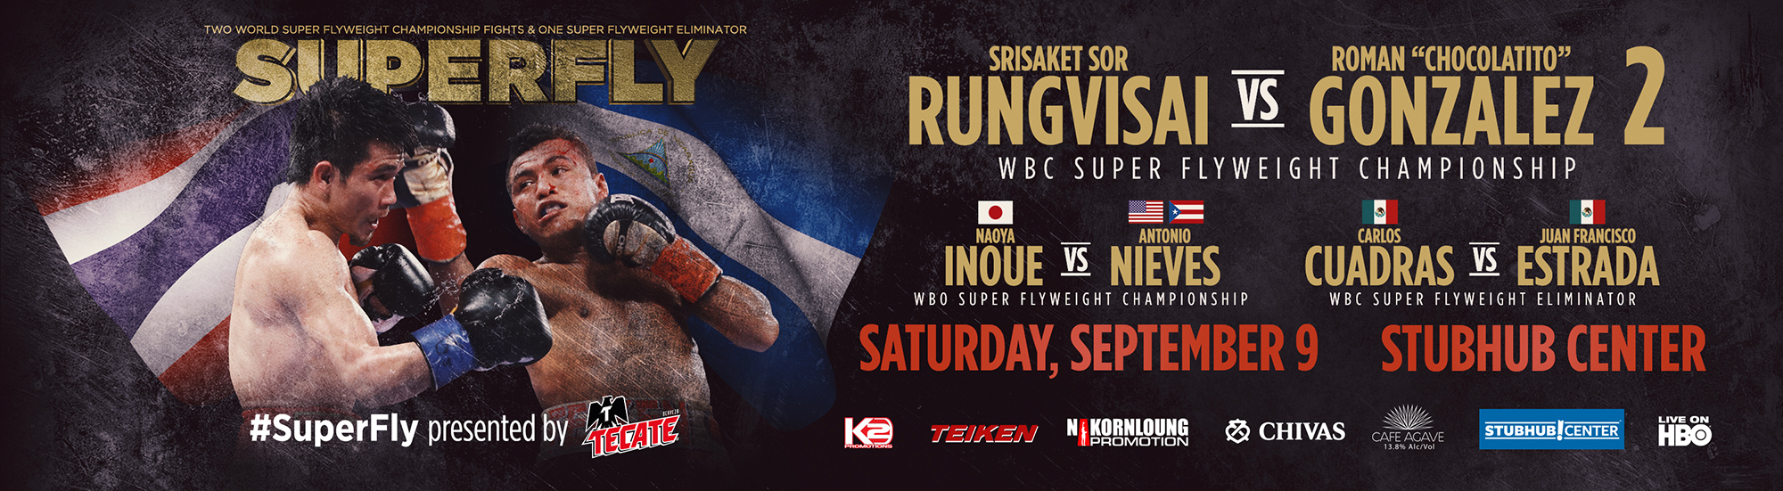
K2 Promotions Presents SUPERFLY
StubHub Center, Carson, CA - Saturday, September 9, 2017
Live on HBO BOXING AFTER DARK
Doors Open: 4:00pm PST – First Bout 4:15pm PST
Photos/Tom Hogan, K2 Promotions
MAIN EVENT -
12 ROUND – WBC SUPER FLYWEIGHT WORLD CHAMPIONSHIP – BOUT 8
SRISAKET SOR RUNGVISAI (115) | Vs | ROMAN GONZALEZ (114.8)
43-4-1 (39KO’s) |  | 46-1-1 (38KO’s)
SI SA KET, THAILAND |  | MANAGUA, NICARAGUA
12 ROUND - WBO SUPER FLYWEIGHT WORLD CHAMPIONSHIP – BOUT 7 –
NAOYA INOUE (115) | Vs | ANTONIO NIEVES (113.8)
13-0 (11KO’s) |  | 17-1-2 (9 KO’s)
YOKOHAMA, JAPAN |  | CLEVELAND, OH
12 ROUND – WBC SUPER FLYWEIGHT TITLE ELIMINATOR - BOUT 6 -
CARLOS CUADRAS (114.6) | Vs | JUAN FRANCISCO ESTRADA (114.8)
36-1-1 (27KO’s) |  | 35-2 (25KO’s)
MEXICO CITY, MEXICO |  | PUERTO PENASCO, SONORA, MEXICO
8 ROUNDS – JR. BANTAMWEIGHT– BOUT 5 -
BRIAN VILORIA (113.4) | Vs | MIGUEL CARTAGENA (113.6)
37-5 (22KO’s) |  | 15-3-1 (6KO’s)
WAIPAHU, HAWAII |  | PHILADELPHIA, PA
8 ROUNDS - LIGHTWEIGHT– BOUT 4 -
RUSLAN MADIYEV (139.4) | Vs | ABDIEL JOSE RAMIREZ (140)
9-0 (4KO’s) |  | 23-1-1 (21KO’s)
KARAGANDA, KZ |  | JUAREZ, MX
8 ROUNDS – JR FLYWEIGHT- BOUT 3 –
SENIESA ESTRADA (106.2) | Vs | ANAHI RAMOS TORRES (107)
10-0 (2KO’s) |  | 16-15-1 (2KO’s)
LOS ANGELES, CA |  | TEXCOCO, MEXICO
4 ROUNDS – JR WELTERWEIGHTS - BOUT 2 –
GEORGE ACOSTA ARREDONDO (136.4) | Vs | DERICK BARTLEMAY  (136.8)
2-0 (1KO’s) |  | 0-5-1
LOS ANGELES, CA |  | PORTLAND, OR
6 ROUNDS - BOUT 1 –
NICK FRESE (145.6) | Vs | NAM PHAN (146.4)
5-0 (5KO’s) |  | 3-2-1 (2KO’s)
BANGKOK, THAILAND |  | FOUNTAIN VALLEY, CA

Saturday, September 9, 2017
Fight Night
Location: The StubHub Center
18400 Avalon Road
Carson, CA 90746
3:30 p.m. – Media Check-In Begins (Box Office Window #12)
4:00 p.m. -- Doors Open
4:15 p.m. -- First Bell
7:15 p.m. – HBO Boxing After Dark
Post-Fight Press Conference, 30 Minutes After Main Event (Media Room)

*Events/Schedule Subject to Change*

SUPERFLY will take place Saturday, September 9 at the StubHub Center in Carson, Calif. and will be televised live on HBO Boxing After Dark® beginning at 10:15 p.m. ET/PT.

Remaining tickets for “SUPERFLY” are now on sale priced at $150, $100 and $60 all of which have limited availability. The $250 and $30 price ranges are sold out. All ticket prices are plus applicable taxes, fees and services charges. Tickets can be purchased at AXS.com, by phone at 888-9-AXS-TIX (888-929-7849), and at StubHub Center Box Office (Monday through Friday from 10 a.m. PT to 6 p.m. PT). VIP Suites are available by calling 877-604-8777. For more information on group discounts or VIP packages, call 877-234-8425. Doors will open on the night of the event at 4:00 p.m. PT with the first bell at 4:15 p.m. PT.

The StubHub Center is located at 18400 Avalon Blvd., Carson CA, 90746 on the campus of California State University – Dominguez Hills. For directions and further information please visit their website at www.StubHubCenter.com

SOCIAL MEDIA:
Hashtag: #SuperFly

TWITTER:
@ChocolatitoBox
@NaoyaInoue_410
@CuadrasOficial
@GalloEstradaOficial
@BrianViloria
@SeniesaEstrada
@TomLoeffler1
@HBO
@HBOBoxing
@StubHubCenter

MEDIA CONTACTS
Bernie Bahrmasel, K2 Promotions: (773) 592-2986, BernieBahrmasel@yahoo.com
Ricardo Jimenez, K2 Promotions: (909) 615-3436, RicardoJ@aol.com
Patrick Byrne, HBO: (212) 512-1361
Kevin Flaherty, HBO: (212) 512-5052
Media Credentials: www.magnamedia.com

